**Project Documentation**

**Global Sales Analytics Dashboard**

Overview

**Project Title:** Global Sales Analytics Dashboard

b. **Project Team:** [List of team members]

c. **Project Duration:** 1 Week

**Project Objectives**

**Objective 1:** Develop a dynamic analytics dashboard for global sales in the e-commerce domain.

**Objective 2:** Extract and transform relevant data from the SQL database.

**Objective 3:** Provide actionable insights to aid decision-making.

**Data Source**

a. **SQL Database:** [Confidential]

b. **Tables Used:** - Orders (Main Fact Table) - Returned (Dimension Table) - People (Dimension Table)

**SQL Queries**

**Query 1: Extract Relevant Data from Orders Table**

*sql SELECT * FROM orders WHERE [conditions];*

**Query 2: Extract Data from Returned Table**

*sql SELECT * FROM returned WHERE conditions [];*

**Query 3: Extract Data from People Table**

*sql SELECT * FROM people WHERE [conditions];*

**Data Transformation (Power Query)**

**Data Cleaning:**

a. Describe steps taken to clean the data.

b. **Data Filtering:**

Specify any filters applied to the data.

c. **Data Aggregation:**

Explain how data was aggregated for better analysis.

d. **Data Reshaping:**

Detail the process of reshaping the data for Power BI.

**Power BI Dashboard**

**Visualizations:**

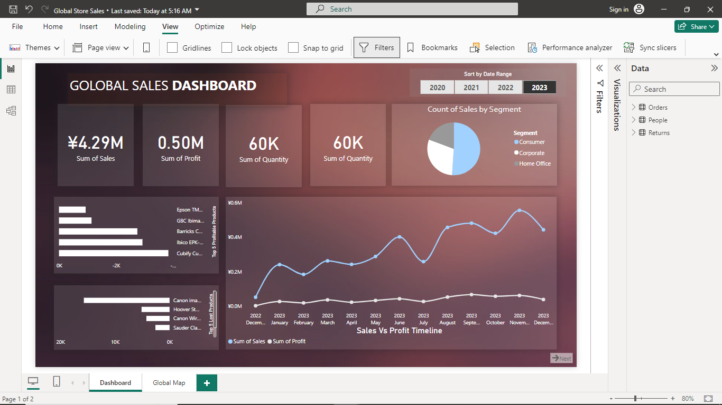.

**Project Challenges**

**Challenges Faced:**

Identify any challenges encountered during the project.

**Solutions:** Provide solutions or workarounds for the challenges.

**Project Results**

**Key Findings:**

The analytics revealed critical insights into the global sales landscape. Key findings included patterns in consumer behavior, enabling the identification of top-performing products and regions. Additionally, the dashboard highlighted trends in returns, shedding light on potential areas for operational optimization. Sales performance metrics provided a comprehensive overview, allowing stakeholders to pinpoint high-impact strategies and make informed decisions. Overall, the analytics facilitated a nuanced understanding of the e-commerce domain, empowering the business to capitalize on opportunities and mitigate challenges effectively.

Top of Form

**Decision Impact:**

The dashboard significantly influences decision-making by providing a visually intuitive representation of crucial business metrics. Decision-makers can swiftly interpret trends, assess the impact of strategies, and identify areas requiring attention. The interactive nature of the dashboard allows for on-the-fly analysis, empowering users to explore data from various angles. This real-time accessibility fosters proactive decision-making, as stakeholders can quickly respond to emerging patterns or challenges. Ultimately, the dashboard serves as a powerful tool, aligning the team with actionable insights and enhancing the agility of decision-making processes in the dynamic landscape of e-commerce.

Conclusion

In conclusion, the Global Sales Analytics Dashboard project achieved success through seamless data integration, robust Power Query transformations, and the development of an interactive Power BI dashboard that provided valuable insights for decision-making. The project excelled in delivering a comprehensive view of global sales, but opportunities for improvement lie in user training for advanced features, implementing automated data refresh mechanisms, ensuring scalability, and establishing a user feedback loop. Addressing these areas will not only enhance the dashboard's current effectiveness but also ensure its continued relevance and adaptability in the evolving landscape of e-commerce analytics

Future Work

Continues Enhancements and benchmarking.